Terraform Documentation

AWS

1. Create an ec2 instance and should have Startup Script to install engine.
2. Properly Tag ALL your resources with the naming conventions and tags.

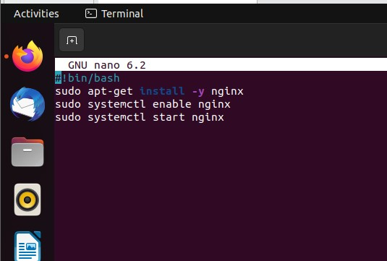

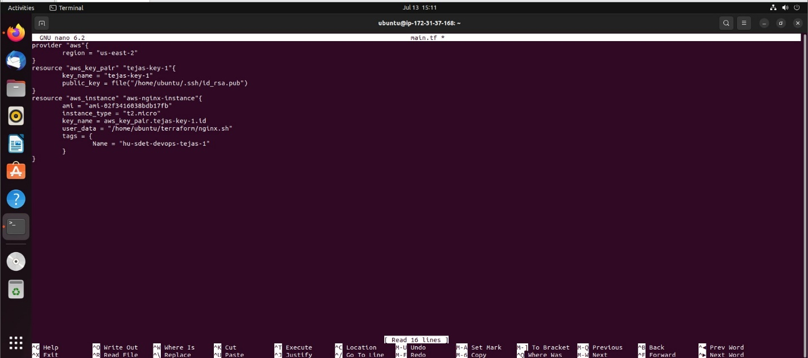

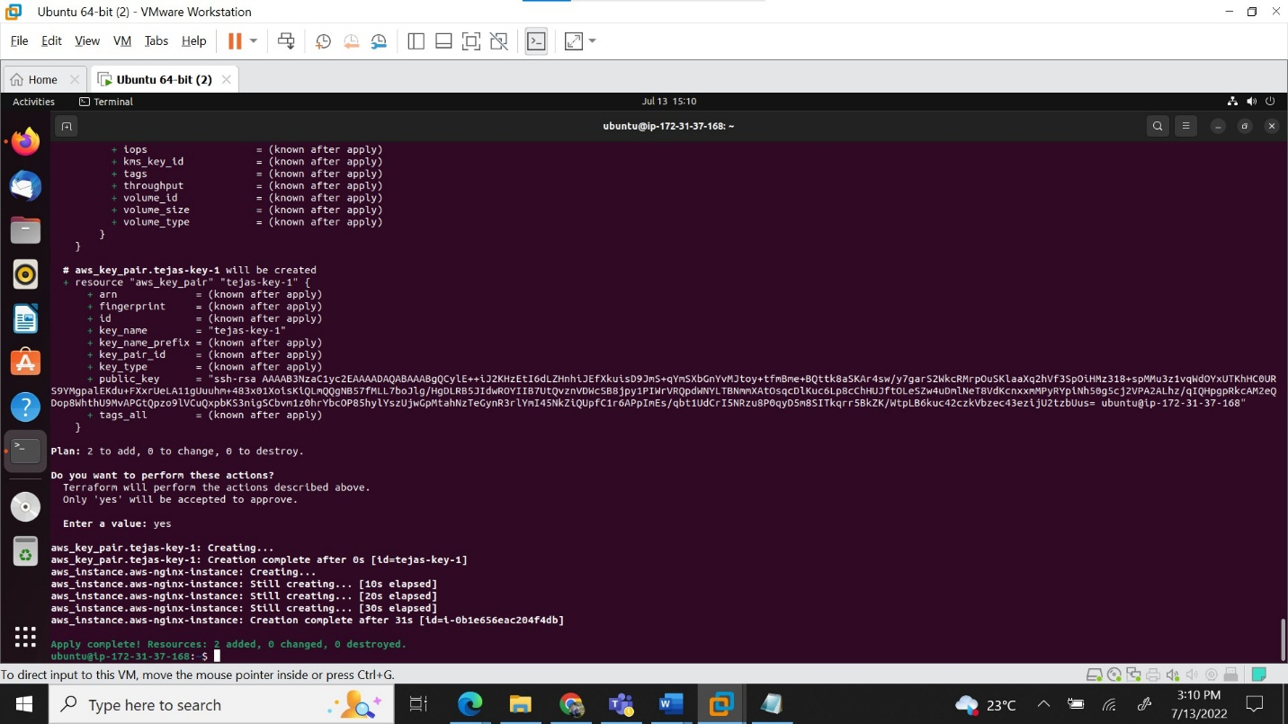

GCP

1. Create a custom virtual machine with 2vCPU and 2GB memory

1. Create a compute instance template

Azure

1. Create a storage container and upload a file from local machine in the storage account.

